* /<https://www.cdc.gov/nchs/surveys.htm>
* <https://www.cdc.gov/healthyyouth/data/yrbs/pdf/2017/2017_yrbs_national_hs_questionnaire.pdf>

92. During the past 12 months, how many times did you use an indoor tanning device such as a sunlamp, sunbed, or tanning booth? (Do not count getting a spray-on tan.) A. 0 times

B. 1 or 2 times

C. 3 to 9 times

D. 10 to 19 times

E. 20 to 39 times

F. 40 or more times

93. During the past 12 months, how many times have you had a sunburn? (Count the number of times even a small part of your skin turned red or hurt for 12 hours or more after being outside in the sun or after using a sunlamp or other indoor tanning device.)

A. 0 times

B. 1 time

C. 2 times

D. 3 times

E. 4 times

F. 5 or more times

25. During the past 12 months, have you ever been electronically bullied? (Count being bullied through texting, Instagram, Facebook, or other social media.)

A. Yes

B. No

87. On an average school day, how many hours do you play video or computer games or use a computer for something that is not school work? (Count time spent on things such as Xbox, PlayStation, an iPad or other tablet, a smartphone, texting, YouTube, Instagram, Facebook, or other social media.)

A. I do not play video or computer games or use a computer for something that is not school work

B. Less than 1 hour per day

C. 1 hour per day

D. 2 hours per day

E. 3 hours per day

F. 4 hours per day

G. 5 or more hours per day

<https://www.skincancer.org/prevention/are-you-at-risk/fitzpatrick-skin-quiz>

Your eye color is:

Light blue, light gray or light green = 0

Blue, gray or green = 1

Hazel or light brown = 2

Dark brown = 3

Brownish black = 4

Your natural hair color is:

Red or light blonde = 0

Blonde = 1

Dark blonde or light brown = 2

Dark brown = 3

Black = 4

Your natural skin color (before sun exposure) is:

Ivory white = 0

Fair or pale = 1

Fair to beige, with golden undertone = 2

Olive or light brown = 3

Dark brown or black = 4

How many freckles do you have on unexposed areas of your skin?

Many = 0

Several = 1

A few = 2

Very few = 3

None = 4

Total score for genetic disposition: _______

How does your skin respond to the sun?

Always burns, blisters and peels = 0

Often burns, blisters and peels = 1

Burns moderately = 2

Burns rarely, if at all = 3

Never burns = 4

Does your skin tan?

Never -- I always burn = 0

Seldom = 1

Sometimes = 2

Often = 3

Always = 4

How deeply do you tan?

Not at all or very little = 0

Lightly = 1

Moderately = 2

Deeply = 3

My skin is naturally dark = 4

How sensitive is your face to the sun?

Very sensitive = 0

Sensitive = 1

Normal = 2

Resistant = 3

Very resistant/Never had a problem = 4

Total score for reaction to sun exposure: _______

Add up your genetic disposition and sun exposure totals to find your Fitzpatrick Skin Type: ___________________

0-6 points = Type I

7-12 points = Type II

13-18 points = Type III

19-24 points = Type IV

25-30 points = Type V

31+ points = Type VI

<https://twitter.com/_nttl/status/728597777098346497>

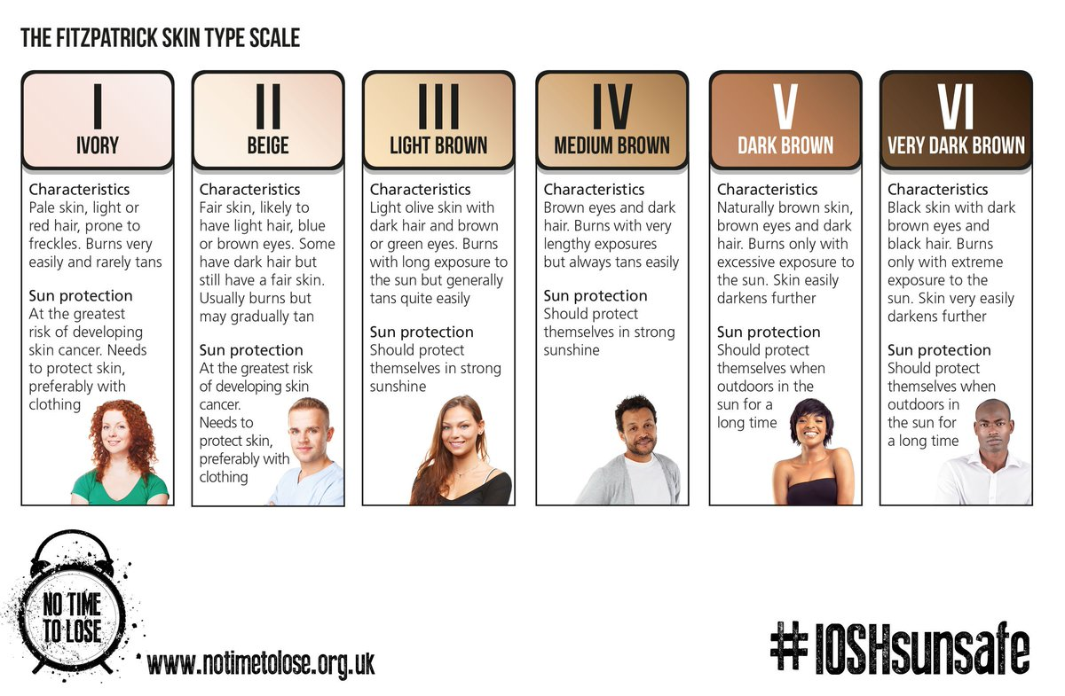

* Questions about awareness of the risks of tanning
* Questions about beauty standards
* Questions about family history
* How old are you?
* What is your gender?
* Do you use social media?
* What social media sites do you most commonly use?
  + Twitter
  + Facebook
  + Tumblr
  + Instagram
  + Snapchat
  + Pinterest
  + Youtube
  + Reddit
* What drew you to use these social media sites?
* How often do you see posts/ads regarding indoor tanning on these social media sites?
* On average, how many days per week do you use at least one of these sites?
* On average, how many hours per day do you spend on at least one of these sites?
* What do you usually do on these social media sites?
* Do you go tanning indoors?
* How long have you been tanning indoors?
* Where do you go tanning indoors?
  + Gym
  + salon
* How often do you tan indoors?
* On average, how long are typical indoor tanning sessions?
* What is your reason for tanning indoors?
  + For vacation
  + For a special occasion
  + To improve mood
* Do you feel attractive after an indoor tanning session?
  + How attractive do you feel?
* Do you use social media more often before, during, or after tanning indoors?
* How hard do you believe it would be for you to quit tanning indoors?
* Are you aware of the risks involved with tanning indoors?

HEALTH RISKS QUESTIONS:

Do you believe that tanning beds are harmful?

Never

Rarely

Sometimes

Most of the time

Always

Socmed ny

Socmed user ny 1 missing

howoften_fb daily, daily multi etc

howoften_tw